SECTION A — Team Information
Field | Response
Team Name | CS309
Project Title | AI Recommender Tool
Semester | Spring 2026
Student Members | Kelly Hwangpo, hwangpoks, hwangpoks@vcu.edu  Jake Carduck, carduckj, carduckj@vcu.edu  Michelle Koh, kohme, kohme@vcu.edu  Dylan Tran, trandn3, trandn3@vcu.edu

SECTION B — Advisor Information
Field | Response
Faculty Advisor Name | Caroline Budwell
Advisor Email | ccbudwell@vcu.edu
Advisor Department | Computer Science
Advisor Role | □ Faculty Advisor □ Sponsor Advisor □ Both
Preferred Communication Method | (Email / Teams / In-person / Other)

SECTION C — Fall Project Continuation Status
Check all that apply:
Project Origin:
□ Continuing Fall 2025 Capstone Project
□ New Project (requires approval)
□ Modified Project (explain below)
If modified, briefly describe changes:

SECTION D — Advisor Confirmation
Choose one:
□ Advisor Signature below
□ Advisor Email Attached
□ Pending Confirmation (must be completed by Week 2)
Advisor Signature (optional): ___________________________
Date: _____________
If signature is not provided, attach email PDF or screenshot.
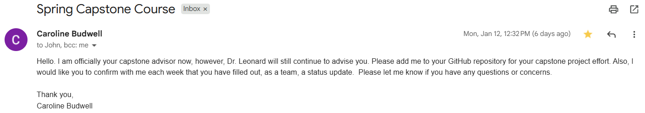

SECTION E — Communication & Meetings
Field | Response
Planned Meeting Frequency | □ Weekly □ Biweekly □ Monthly □ Other
Planned Meeting Time | Monday, 2-3PM
First Meeting Scheduled? | □ Yes (Date: _01.13.26_) □ No □ Pending
Sponsor Involvement (if applicable) | □ Yes □ No
Sponsor Name (if applicable) | Lakshmi Narayana Rasalay, Capital One  Nabin Debnath, Capital One
Sponsor Email (optional) | LakshmiNarayana.rasalay@capitalone.com  nabin.debnath@capitalone.com

SECTION F — Spring Deliverables Awareness
Team acknowledges that Spring includes:
✔ Expo Poster
✔ Expo Demo
✔ Final Report
✔ Advisor Sign-off
Team Confirmation (initials): _KH, JC, DT, MK__

SECTION G — Risk Indicators (Early Detection)
Check if applicable:
□ Missing teammate(s)
□ Advisor unavailable or unresponsive
□ Sponsor unavailable
□ Scope unclear
□ Technical blockers anticipated
□ Unsure about Expo expectations
□ Unsure about Final Report expectations
□ None identified
If any selected, explain:
- Lack of response to discord messages
- Problems involving AI and APIs working
- Need more detail for Expo expectations (Uncertainty)

SECTION H — Submission Certification
By submitting, the team confirms that:
✔ Team membership is accurate
✔ Advisor information is accurate
✔ Advisor confirmation is in progress or completed
✔ The project is valid for continuation to Spring Expo phase
Submitted by (Team Representative): __Kelly Hwangpo___
Date: __01.18.26__

